Stage 4 ★
Mixed Selection 2 - Solutions

- Penny farthing
As the ratio of the radii is $3:4$ the number of revolutions made by the larger wheel is $12000×\frac{3}{4}=9000$.

- Tadpoles
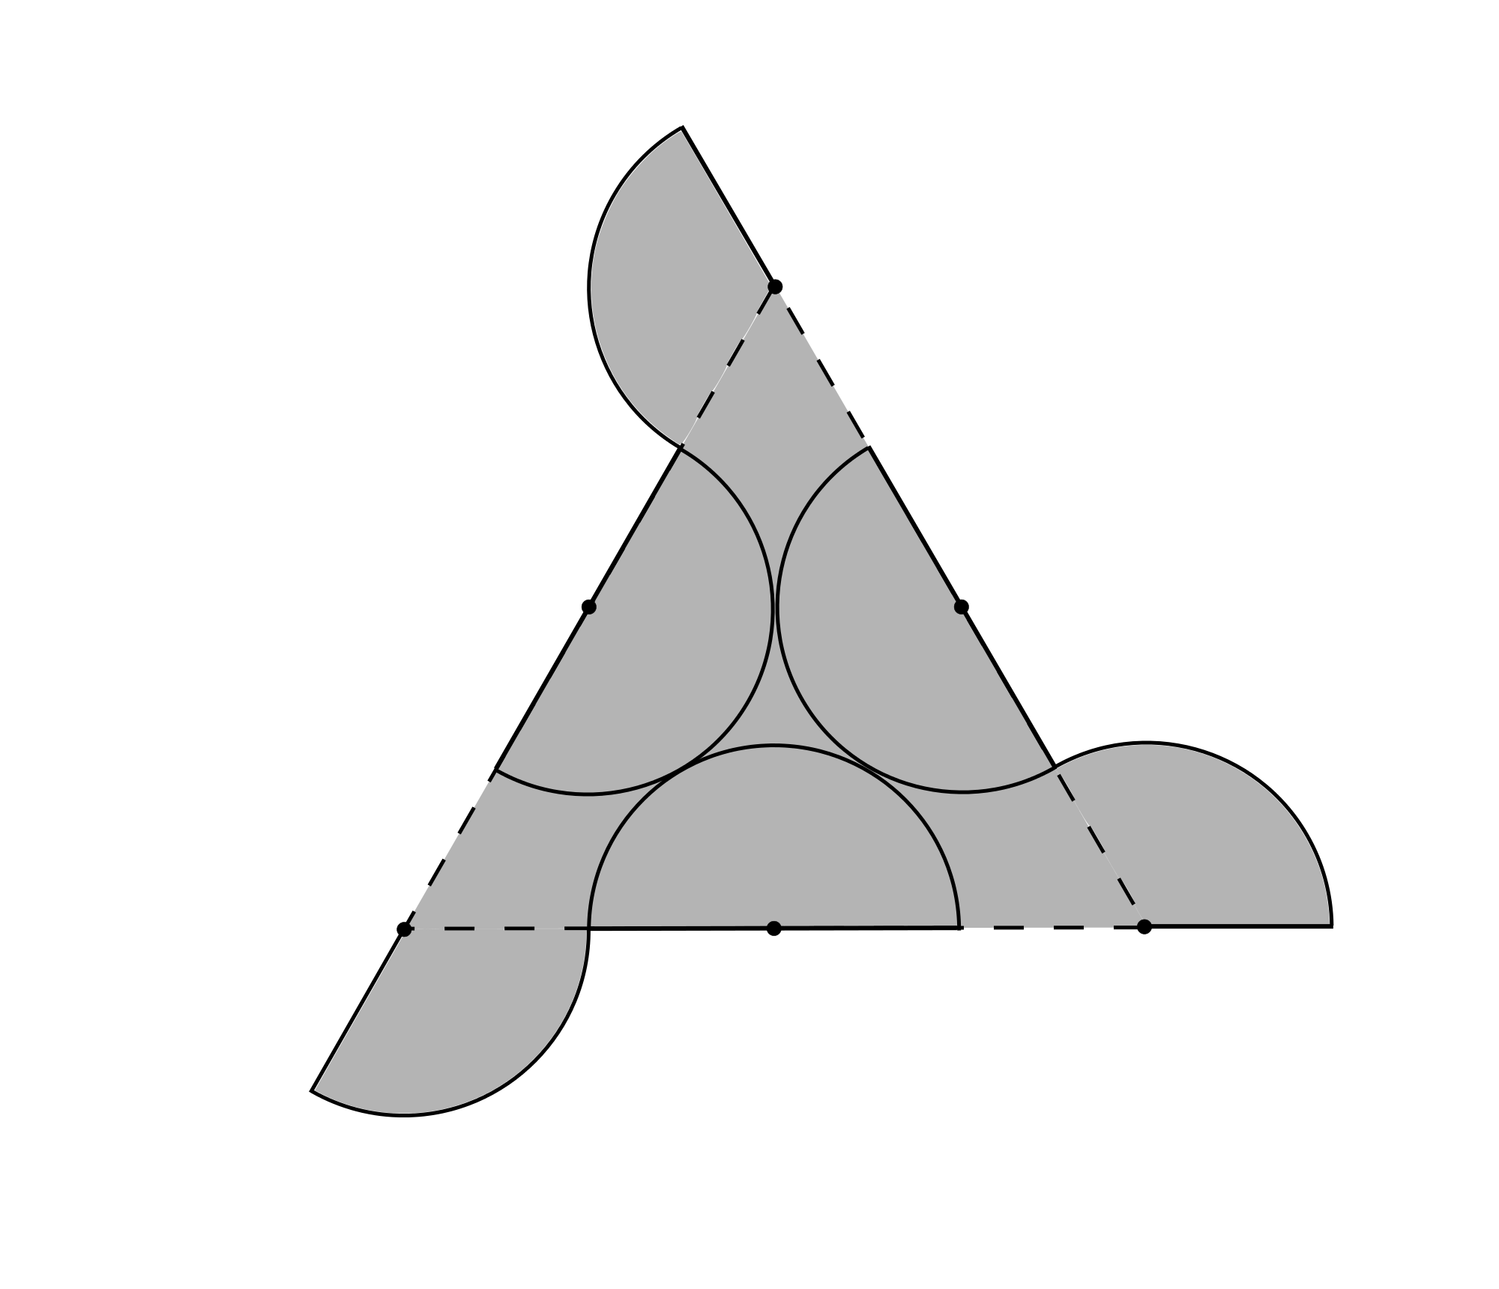
The length of the side of the triangle is equal to four times the radius of the arcs. So the arcs have radius $2÷4=1/2$. In the diagram above, three semicircles have been shaded dark grey. The second diagram shows how these semicircles may be placed inside the triangle so that the whole triangle is shaded.
Therefore, the difference between the area of the shaded shape and the area of the triangle is the sum of the areas of three sectors of a circle. The interior angle of an equilateral triangle is $60°$, so the angle at the centre of each sector is $180°-60°=120°.$
Therefore, each sector is equal in area to one-third of the area of a circle. Their combined area is equal to the area of a circle of radius $1/2$. So the required area is $π×{\left(\frac{1}{2}\right)}^{2}=\frac{π}{4}$.

- Square Flower
The square has side length 2, so each of the circles has radius $\frac{1}{2}$.
The circumference of a single circle, $2πr$, is therefore $π$.
The shaded region is bounded by$4$ halves of a circle and $4$ quarters of a circle.
Therefore the length of the perimeter of the shaded region is

$$\left(4 ×\frac{1}{2}+4×\frac{1}{4}\right)π=3π$$

- Crazy shading
The middle sized square passes through the centres of the four circles. Each side of the middle sized square together with the edges of the outer square creates a right angled isosceles triangle with angles of 45∘. Thus the angles these sides make with the inner square are also 45∘. Each side of the middle sized square bisects the area of the circle. The inner half of that circle is made up of two shaded segments with angles of 45∘ which together are equal in area to the unshaded right angled segment. Thus the total shaded area is exactly equal to the area of the inner square and hence equal to one quarter of the area of the outer square.

